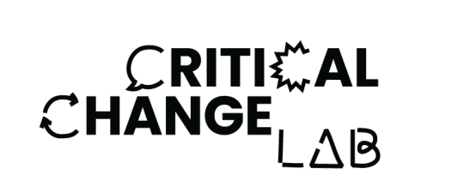
Registration of Interest & Consent Form
Complete this application form by 8th September and email it to info@thedigitalhub.com or post / drop-in to Digital Depot, Roe Lane (off Thomas Street), The Digital Hub, Dublin 8, D08 TCV4.
DETAILS OF YOUNG PERSON APPLYING TO THE COURSE

NAME & SURNAME
AGE
NAME OF THE SCHOOL ATTENDED

DETAILS OF PARENT/GUARDIAN

NAME & SURNAME

EMAIL ADDRESS

MOBILE

ADDRESS

This information will be used for the recruitment process and delivery of the course and will be stored confidentially by The Digital Hub and Trinity College Dublin. It will not be shared to any further party.

Please tick this box if you are happy to be contacted by The Digital Hub or Trinity College Dublin regarding further courses/ events. You can withdraw this consent at any stage by contacting The Digital Hub or Trinity College Dublin.

Date:

Signature:

Consent Form

The Digital Hub Development Agency and Trinity College Dublin recognise the need to ensure the welfare and safety of all young people taking part in any activity associated with our organisations.

In accordance with our child protection policy, we will not permit photographs, video or other images of young people to be taken without the consent of the parents/carers and children.

As your child will be taking part in the Critical Change Lab at The Digital Hub, we would like to ask for your consent to take photographs/videos of the event or activity that may contain images of your child.

It is likely that these images may be used as:

- a record of the activity or the event
- in a written evaluation report of the activity or event that will be viewed by The Digital Hub Development Agency, Trinity College Dublin or other stakeholders.
- publicity material for further activities or events on leaflets/websites/magazines
- illustrations of the activities or events in published articles
- future grant applications

The Digital Hub Development Agency and Trinity College Dublin will take all steps to ensure these images are used solely for the purposes they are intended. If you become aware that these images are being used inappropriately you should inform The Digital Hub/BIMM Institute Dublin immediately.

I (Guardian/Parent) consent to the Digital Hub Development Agency

photographing or videoing (Participant) .

Signature:

Date:

